A New REMOTE Demo in the Canary Islands
The Consortium strengthens its competence with three Spanish partners:
Inycom, ITC e Capisa

A new installation and a change in the design of the international Consortium are the focus of the news inside the REMOTE project.

The EU funded project leaves continental Europe, landing in the Atlantic Ocean, specifically in Aldea de San Nicolas village - Gran Canaria Island (Spain). The new demo will provide 100 kW of power capacity inside a cattle farm that is being expanded, under the technical management of the incoming partners Inycom, ITC and Capisa. The new plant will produce electricity by exploiting local solar and wind energy with the help of an hybrid hydrogen/battery storage system, to improve the reliability of the power supply service and reduce the use of diesel generators.

Let’s see who are the incoming Partners and their role within the Consortium. Inycom is a Spanish company skilled on advanced technical solutions in the energy, environmental, transport and telecom fields. It plays the role of System Integrator. ITC, the Canarias Institute of Technology linked to the Regional Ministry of Economy, is specialised in the implementation of renewable energy systems in the area; it plays the role of Facilitator for the demo implementation. Capisa is the end user. It is a company leader in the production and distribution of animal feeds and in livestock activities at the Canary Island. Thanks to the REMOTE project it will recover functioning costs and decrease environmental impact through the demo installation.

Another relevant change in the REMOTE project is the dismissal of the two Italian demo sites planned in Ginostra (Stomboli Islands - IT) and Ambornetti (Italian Alps) and then, the outgoing from the Consortium of the corresponding end-users Partners: Enel Green Power and IRIS.
Nevertheless, Enel Green Power and IRIS remain involved in the REMOTE framework, bringing their expertise to support the success of the project as members of the Advisory Board and enforcing the exploitation actions thanks to their considerable knowledge of the energy market.

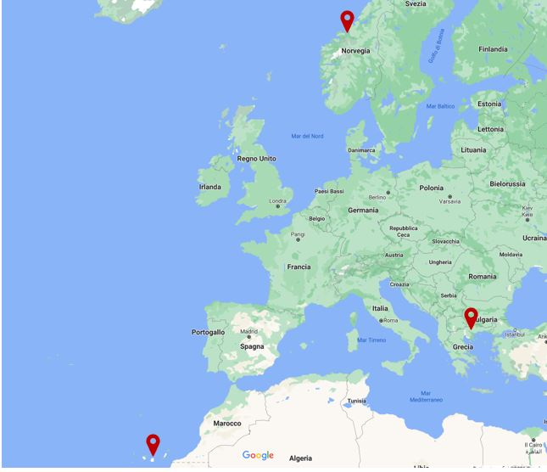

According to the above changes, the current REMOTE project has the aim to achieve three demos: in Gran Canaria (Spain), Agkistro (Greece) and Rye (Norway), through the direct involvement of Politecnico di Torino, as Coordinator of the Consortium, and Ballard Power Systems Europe, Hydrogenics Europe, Powidian, Orizwn, Tronderenergi, SINTEF, ENGIE -EPS, CERTH, Inycom, ITC and Grupo Capisa, as Partners.

More details on the Remote challenging activities are available at: https://www.remote-euproject.eu/

The REMOTE project has received funding from the Fuel Cells and Hydrogen 2 Joint Undertaking under grant agreement No 779541. This Joint Undertaking receives support from the European Union’s Horizon 2020 research and innovation programme, Hydrogen Europe and Hydrogen Europe research.

REMOTE contacts:
https://www.remote-euproject.eu/
remote@polito.it

