REMOTE project comes to reality with the first installation
In Rye, Norway, the power-to-power plant will produce and store renewable energy with the use of hydrogen

REMOTE (Remote area Energy supply with Multiple Options for integrated hydrogen-based TEchnologies) is an EU-funded project coordinated by Torino Polytechnic, aimed to demonstrate the advantages of hydrogen-based Power-to-Power systems for renewable energy storage. The systems allow isolated and off-grid areas to get access to a continuous source of energy coming from local renewable resources. The storage helps to overcome the intermittency of renewable energies, which is a limit of their use in the remote and off grid areas.

The first North Europe demonstration site is ready to start in Rye, where renewable energy is produced from a local wind farm and solar power station, owned by Tronderenergi. The fuel cell system and the hydrogen tank have been delivered, and the complete system will start its operation in April 2020. The power-to-power system is composed by a fuel cell supplied by Ballard Power Systems Europe, an electrolyzer from Hydrogenics Europe and the whole integration has been carried out by Powidian. The system will produce energy from the local wind turbines and solar panels, and extra-energy will be stored in the hybrid battery-hydrogen storage system, to be re-used to cover the loads of the farm.

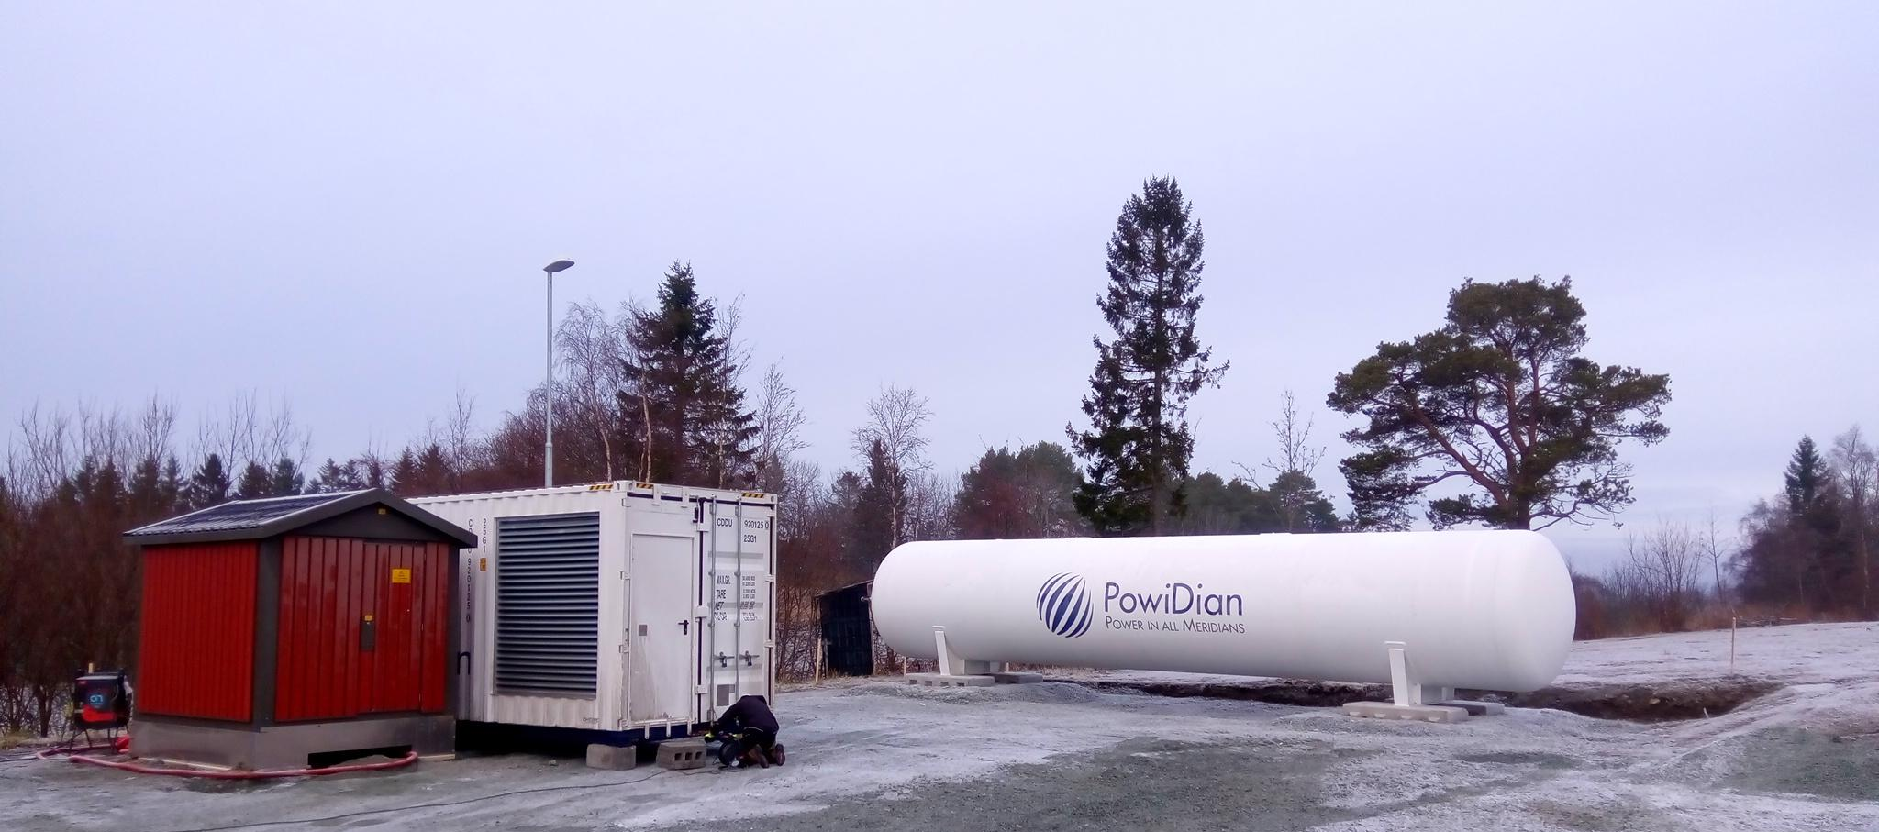
The fuel cell container and the hydrogen tank are ready to be started in Rye, Norway.

The Rye demo site is composed of a 100 kW Proton Exchange Membrane (PEM) fuel cell and a 55 kW PEM electrolyzer. The storage includes both a 3333 kWh hydrogen tank and a 550 kWh Li-ion battery. Local renewable energy sources are an existing wind farm (225 kW) and a PV plant running since March 2019 (85 kW).
The annual energy required by the load (a local farm) site is around 130 MWh (with a 70 kW peak load). The total yearly energy from renewable energy is about 280 MWh (200 from wind and 80 from PV) but energy production (which depends on wind and sun availability) does not match the farm request. Thanks to the H2-based storage system, the site will be able to almost fully cover the loads with renewable sources.
Techno-economic analysis carried out by SINTEF have shown that the solution is a viable and cost-efficient way of delivering renewable energy to remote, stand-alone micro-grids, compared to the costs of alternatives, such as grid connection or the use of fossil fuels.
The REMOTE project aims to install four power-to-power hybrid systems in 4 EU remote areas located in Norway, Italy and Greece. The other three DEMO sites are the following:

- Ginostra (South of Italy, Stromboli island, off-grid area)
- Agkistro (Greece, isolated micro-grid application)
- Ambornetti (North of Italy, mountain hamlet, off-grid area)

_____________________________________________________

This project has received funding from the Fuel Cells and Hydrogen 2 Joint Undertaking under grant agreement No 779541. This Joint Undertaking receives support from the European Union’s Horizon 2020 research and innovation programme, Hydrogen Europe and Hydrogen Europe research.

https://www.remote-euproject.eu/

Contact: remote@polito.it

