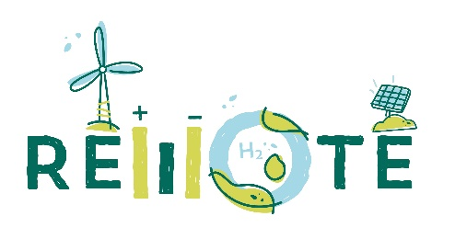
PRESS RELEASE

Bringing clean and innovative energy storage solutions to REMOTE isolated areas
The EU-funded project aims to install 4 hybrid power-to-power storage systems in isolated areas of Italy, Greece and Norway

There are more than 10’000 populated islands around the world and an estimated 750 million islanders. Many of these islands, especially those in the range of 1’000 to 100’000 inhabitants each, rely on diesel generators for their electricity production and spend a considerable percentage of their GDP on the import of fuels. Furthermore, many more other isolated situations (mountains, remote areas) exist.
As an example, Italy has 77 islands in the sea, 23 in lakes and one in a river. Mediterranean populated islands are 158, with a population ranging from 5 million (Sicily, IT) to 1-2 inhabitants (Montecristo and Asinara, IT and Schiza, GR). 40.5% of the Mediterranean islands have less than 1’000 inhabitants, and 29.7% less than 500. Most of Mediterranean islands are not connected to the national grid.
The exploitation of local Renewable Energy Sources (RES) is a key step for the innovation process of these locations toward a cleaner energy production path. However, solar and wind show the issue of intermittency and the mismatch between the energy production and the demand side. This criticality has to be solved and one significant option is to develop bulk energy storage solutions for electricity that are cost-effective, energy dense, reliable.
The REMOTE EU Horizon2020 funded project, developed under the coordination of Politecnico di Torino together with 10 european partners, has the aim to demonstrate the technical and economic feasibility of two H2-based energy storage solutions (one integrated P2P system and one non-integrated P2G+G2P system).
Four DEMO sites supplied by renewable electricity will be installed in either isolated micro-grids or off-grid remote areas of northern and southern Italy (Ambornetti and Ginostra), Greece (Agkistro), Norway (Froan island).
Intermittent Renewable Energy Source (RES) – PV, wind, wave – integrated with an H2-based power- to-power (P2P) storage system can provide a viable, reliable, cost- effective, and decarbonized alternative to on-site electricity generation through diesel engines.
The four REMOTE DEMO sites have been chosen to obtain a mix of different renewable sources tested in different contexts from the sunny and hot southern Europe up to the windy and cold Scandinavia or the specific climate of Italian Alps. To provide reliable and clean energy to local population is a technical challenge with a strong social impact, as cheaper, available and green energy is one of the basic brick for economic development. All the sites will experience an almost complete substitution of fossil fuels (with some of them reaching zero need for fossil fuel). Experience gained in isolated and off-grid remote areas will pave the way for the deployment of H2-based storage solution at large scale.

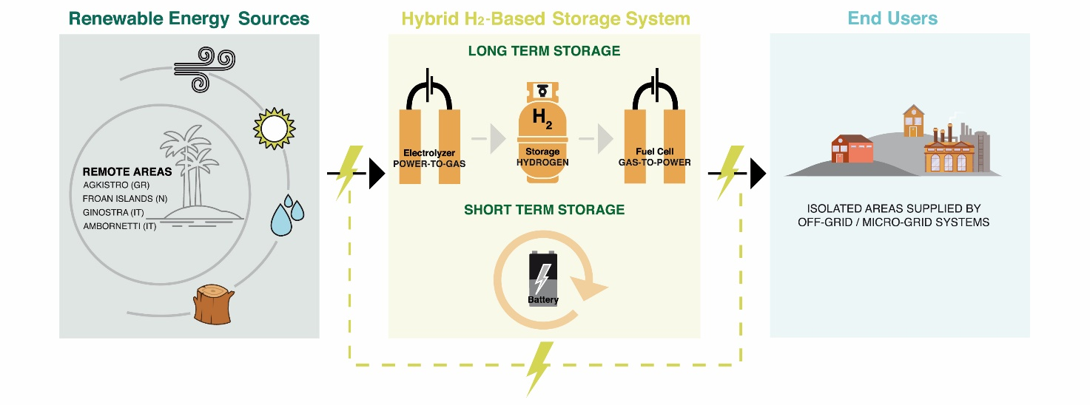
The project coordinated by Politecnico di Torino (IT) has the following partners: Ballard Power Systems Europe (DK), Hydrogenics Europe (BE), Powidian (FR), Enel Green Power (IT), Orizwn (EL), IRIS (IT), Tronderenergi (N), SINTEF (N), EPS ELVI Energy (IT), CERTH - Ethniko Kentro Erevnas Kai Technologikis Anaptyxis (GR). .

This project has received funding from the Fuel Cells and Hydrogen 2 Joint Undertaking under grant agreement No 779541. This Joint Undertaking receives support from the European Union’s Horizon 2020 research and innovation programme, Hydrogen Europe and Hydrogen Europe research.

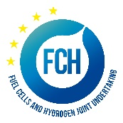

Contacts:
Website - https://www.remote-euproject.eu/
Email - remote@polito.it

